Tour Of Sardinia 2011
Stage 2 (Lun) | Stage 3 (Mar) | Stage 4 (Mer) | Stage 5 (Gio) | Stage 6 (Ven) | Stage 7 (Sab)
GiroSardegna 2011 |  | GranGiro |  | MedioGiro
Total : |  | km 554 |  | km 476
Overall : |  | m 5369 |  | m 3960
Prizes: |  | The first three overall winners (men/women) of the GranGiro and the MedioGiro and the first three in each category.
Saturday 23 April: arrival at the hotel
The headquarters of the week's cycling is at the 4 Stards Resort “Horse Country” in Arborea .

Arrivals are expected on the afternoon of Saturday 23rd; you can arrive in the morning as well but the cost of any meal before dinner on 23rd is not included in the price-
Giving out of race numbers and chips for the time trial (for the entrants in the Giro, Tour and 1000K and the Granfondo) will begin on Saturday afternoon (from 1700 till 2000) or directly at the start of the race on Sunday morning.

Sunday 24 April: Individual Time Trial
- Starts: MedioGiro/GranGiro from 08.00 till 13.00; Tour: at any time
- Feed stops : none (only water at the start/finish line)
- Prizes for the day : the first three overall winners (Men/women) of the GranGiro and MedioGiro + raffle amongst those present.

Easter day and we will be in an area without any towns, so there will not be much traffic on the roads and we will pedal an absolutely flat course (it is an old swamp which has been drained and cultivated). The race is in fact on a straight road with four bends, a U-turn and three/four roundabouts! So, really, you can all go for it!
The race starts will be strictly in order of the race numbers which are assigned progressively according to the dates of birth of the riders and the chosen course.
We will be very careful to avoid anti-sporting behaviour and, if there is any, it will be severely punished by the judges who will also take into account "photographic proof" taken by the staff at the checkpoints of the course and the motorcyclists of the organisers.
In warming up you should avoid going on the race course (you can use the many existing parallel roads); in particular "friends" of the cyclists should carefully avoid "meeting up and following on" in the course if they do not want to run the risk of being disqualified on the first day!
Single course for all (GranGiro/MedioGiro) 24 k (no climbing)
The race course goes from the hotel to the bridge at the Marceddì fish farm; then you turn round and come back to the hotel!
You will find the first bend after 9 k. There isn't even a flyover nor a house: only four/five crossroads which will be controlled by our staff
Green route-Tour: free day
This is the ideal day for riding around the area at your leisure; avoid the race course and take one of the many parallel roads which take you to Marceddì (go across the bridge on the bike and you will reach the lake full of fish) and while you are there, pedal around Arborea, a village built only 70 years ago after the draining of the swamp.

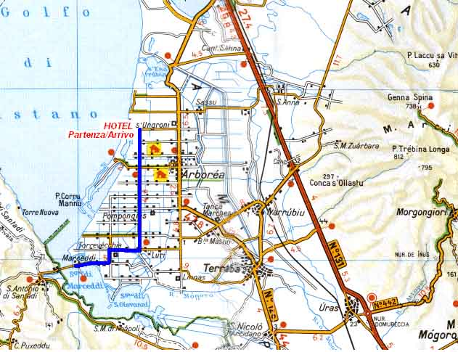
NOTE: : "Our" Resort is also a famous and well-equipped centre for horse riding of international reknown. To celebrate Easter and the arrival of guests, we will hold the prize-giving at 1800 in the majestic "Palacavallo" (one of the biggest covered horseriding schools in Europe, holding over 1000 spectators) where there will be an exhibition of Sard handicrafts. In the traditional and colourful show, the horse riders, dressed in typical Sard costumes, will ride in a stirring parade (lasting 1h20m). Entrance free to all.
Monday 25 April - Granfondo Sardegna – The Costa Verde-
- Rally of participants at the Horse Country Resort at Arborea (OR)
- Race start : MedioGiro 9.00 – GranGiro 9.15; Tour : free start between 8 and 9.
- Maximum time at finish : MF 13.30; GF 16.00 .
- Feed stops : MedioGiro 1+at finish; GranGiro 2+at finish; Tour 2, start and finish
- Prizes : the first three overall winners (men/women) and the first three in each category both for the Granfondo and for the Mediofondo

Giving out of race numbers for the entrants for the day will be on Saturday 23/04 or before the start from 0730 till 0900.
N.B. - the entrance fee for the “GF Sardegna” is 15 euros if made before Saturday 9/4, rising to 20 Euros till the afternoon of Saturday 23/4 and to 25 Euros the morning of the race. Entrance does not include freebies nor the “pasta party” lunch at the end of the race.
The Giro riders (GranGiro, MedioGiro, Tour and 1000 k Sardegna) will use the same numbers as the Giro and do NOT need to send any further entrance fees for this race.
The race will take place in a less well-known part of Sardinia where there are no hotels; here there is an endless series of old mine workings now abandoned and the few roads that exist were used only for mining.
Near the mine works there were villages which were then abandoned and have fallen into disuse; then the public authorities bought everything for a project in “mining archaeology” which is to become a tourist attraction.
The whole coast is unmatched for the roads through mountain coloured by the natural minerals, the enormous sand dunes (Piscinas, Torre dei Corsari, etc) and for the absence of any hotel buildings: therefore it is even more “wild” with sections on unmade roads and fording little streams which’ll be some of the things you’ll remember from this Granfondo.
Another characteristic of some importance is that for the whole course of the mediofondo you do not go into any towns ( you barely touch Guspini) and in the granfondo you pass through only Arbus: it is all just pure nature !
The Granfondo Sardegna is the second stage of the GiroSardegna but it can also be ridden independently; so cyclists who are not taking part in the rest of the week can participate; there will also be cyclists from the “mainland” participating in the “Giro d’Italia” of the UISP and there will also be Sard cyclists riding in what is the most important race of the year on the island.
The riders of the GiroSardegna will recognise each other because the will have race numbers which show the rider’s name and have different colours for each age category; the entrants for just the day will have just the race number on a white background
The start will be according to the chosen course (Grangiro/Granfondo or MedioGiro/Mediofondo) and entrance into the grid will be made according to when riders arrive at the start. At the end of the race there will not be a ”pasta party” but only a final feed stop. In the afternoon, around 1600, at the meeting centre we will hold the prize giving for the overall and age category winners.

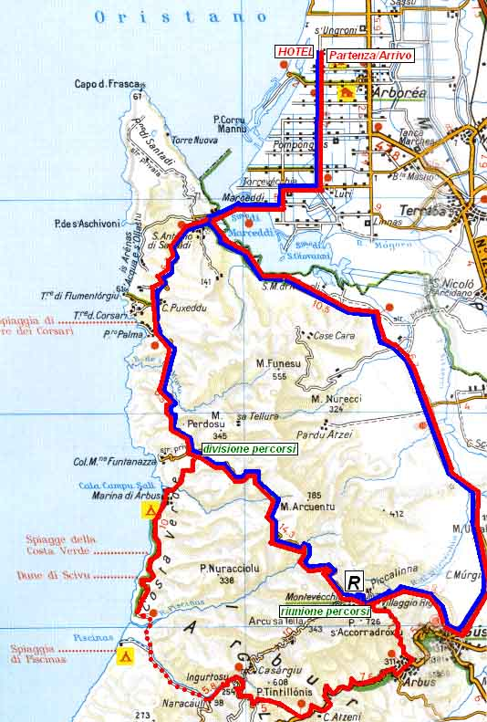

Blue Course-MedioGiro/Mediofondo km 92 (overall climbing m. 652)

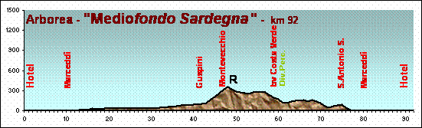

From the hotel go to the fishing area of Marceddì (the same road as the time trial on the first day), then cross the narrow bridge which takes you to the lake where you make another 30 k on the flat until you reach the edge of Guspini where the climb starts that takes you to the old mineworks of Montevecchio and the little uninhabited village of the same name where there is a feeding point. >From there, the road takes you to the distinctive Monte Arcuentu and you then descend towards the sea. At the 60k mark, there is a split in the two courses. The medio fondo riders turn right and after several ups and downs you end up back at the bridge at Marceddì which you cross to make the last 12k of flat riding to the finish line for the final sprint.

Red Course-Granfondo km. 145 (overall climbing m. 1.509)
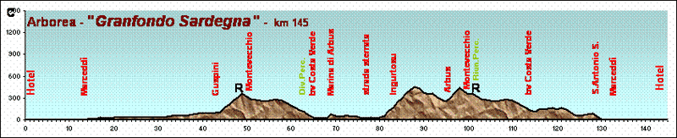

The riders in the granfondo do the same course (Marceddì, Guspini); so for them too there is the feed stop at Montevecchio and then the road to monte Arcuentu but at the split they turn left and pedal along the seaside of the Costa Verde. The coastal part starts at Marina di Arbus (a poorly constructed tourist village) and then goes into the countryside which becomes ever more wild: after 10k of seaside the asphalt road ends. You then pedal 5k on a very good unmade road to the dunes of Piscinas , which at first takes you over two fords (we will build little crossings … but the temptation make you cross the little streams with the bike on your shoulder is strong!!!) and so to the ruins of the old abandoned mine works of Ingurtosu. Well before the “ghost village”, when you reach the asphalt road, there is the start of a long hard climb which takes you to the pass at 600m , then you ride down again as far as Arbus where you start to climb again in a gradual way and then, just outside the village, a bit more steeply, on a very beautiful panoramic road which takes you back to Montevecchio where you find the feed stop. Then there is another descent on the road to Monte Arcuentu which you follow to get to the bridge at Marceddì and then do the last flat 12k to the finish line. It is a very special unique course, which will stay fixed in your memory!

Green Course-Tour km 50 (overall climbing < 1000 m)
You can peacefully go round the hotel and pedal at your leisure …. But if you like, you can also take your car to Montevecchio, get on the bike there and do the grangiro course from the feed stop (Marina di Arbus, Costa Verde, then the unmade road at Piscinas and then Ingurtosu). At the mining village you can continue to climb as did the riders in the granfondo to the pass ( then Arbus and then again to Montevecchio) or, even better, go back to Montevecchio on the unmade road for 10k which stays high without much climbing; in any case, you get back to your car at the feed stop and go back to the hotel.
Tuesday 26 April: the inland villages

- Race start : MedioGiro 9.00 – GranGiro 9.15; Tour : free start between 8 and 9.
Maximum time at finish : MG 13.00; GG 13.30
Feed stops : MedioGiro 1; GranGiro 1; Tour none
Prizes : the first three overall winners (men/women) for the Granfondo and for the Mediofondo + raffle prizes amongst those present

A long fast stage, essentially on the plain, which goes into the inland area of the plains of Oristano; passing through a long series of little sleepy villages where life goes slowly and quietly to arrive finally at the slopes of the Giara di Gesturi and then we turn back for the final sprint.

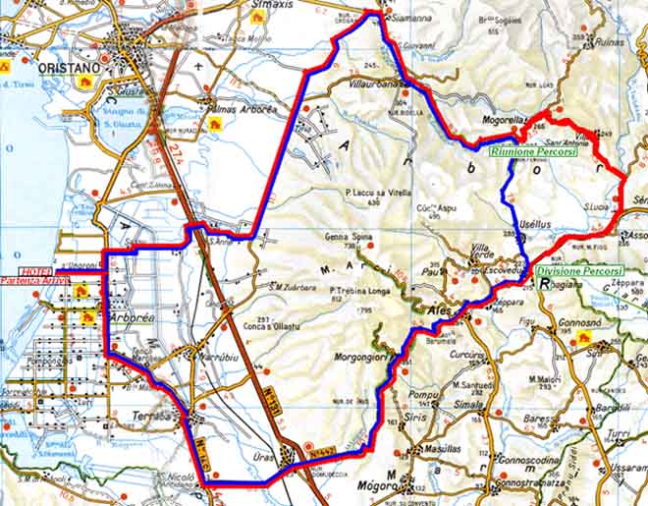

Blue Course-MedioGiro km 94 (overall climbing m. 670)

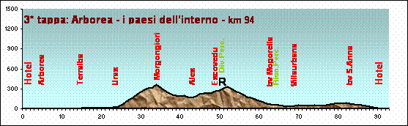

You leave the hotel at a controlled speed (behind the race car) and cross through the villages of Arborea and Terralba and then immediately start to race. More flat to get to S.Nicolò d’Arcidano and Uras then you climb slowly but steadily up to 400m at Morgongiori then stay high to get towards Ales and then Escovedu where there is a feed stop and the course splits. The riders in the medio fondo turn left and go through Usellus and then descend to Mogorella then to Villaurbana and finally to Siamanna. Then a long straight flat road takes you to the finish line: there will be some large group sprints, we are sure.

Red Course km. 105 (overall climbing m. 860)

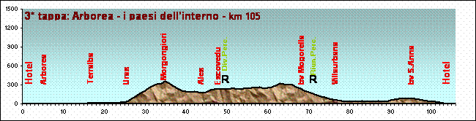

The same flat route as for the medio as far as the feed stop at Escovedu where you go straight on for a few more kilometres then turn towards Villa S.Antonio and Mogorella going on till you meet the common route which goes down again to Villaurbana, Siamanna and so to the finish line at the hotel.

Green Course-Tour km 50 (overall climbing m. 100 circa)
Keep on the race course as far as Uras and then immediately after you go over the SS 131, take the local road which goes along beside it; stay on this road (which is absolutely flat and free of traffic) always keeping the big highway on your left. Go across the turns for Terralba and Marrubiu until you find yourself on the race route again. A very relaxing route but…..ABSOLUTELY DO NOT get onto the highway

Wednesday 27 April: Lake Omodeo
- Race start : MedioGiro 9.00 – GranGiro 9.15; Tour : free start between 8 and 9.
Maximum time at finish : MG 13.00; GG 13.30
Feed stops : MedioGiro 1; GranGiro 1; Tour none
Prizes : the first three overall winners (men/women) for the Granfondo and for the Mediofondo + raffle prizes amongst those present

Another long stage which starts with many kilometres of flat then, the central part (especially for the GranGiro), some climbing will break up the rhythm of those less strong, but there are more flat kilometres at the end where you can hope to recover and make an impact in the final sprint. It is a beautiful fast stage which will help you discover the real heart of the Island which is unknown but which deserves a much greater flow of tourists.

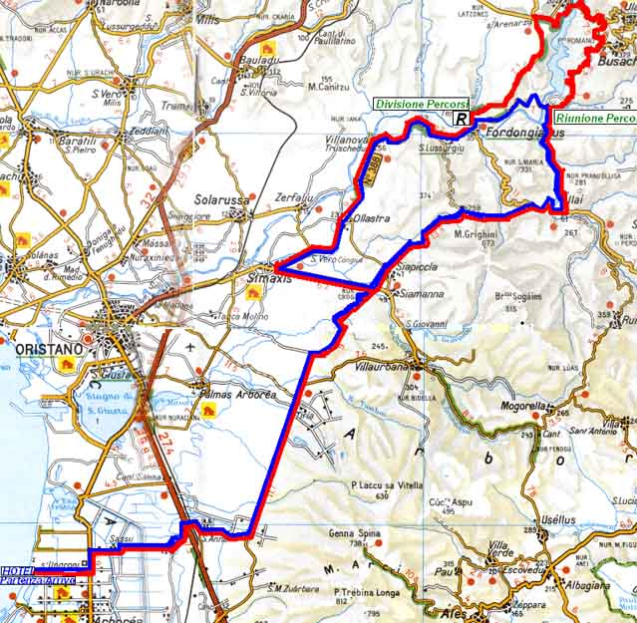

Blue Course-MedioGiro km 100 (overall climbing m. 730)

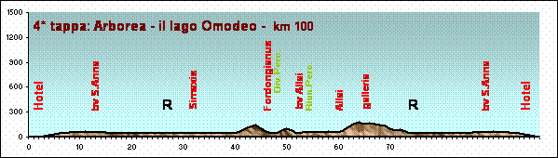

A backwards rerun of the course of the day before reaching after 30k on the flat the roundabout of Siamanna where there is the feed stop. Then you follow, still on the flat, the road for Simaxis, S.Vero C., Ollastra and Villanova Truschedu. A few ups and downs take you to Fordongianus (famous for its hot thermal springs used since the days of the Roman empire) and just outside the village you cross the river Tirso and there is the split in the two courses. The mediofondisti go right following the course of the river which thery cross back over near the old dam. On the other side they rejoin the course of the GranGiro which we follow together as far as Allai. A few kilometres of climbing takes you to the new road which very quickly takes you to the roundabout at Siamanna where you find the feed stop. And from there to the finish line.

Red Course km. 114 (overall climbing m. 1092)

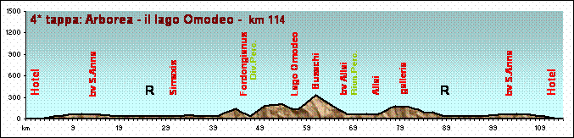

The granfondo riders also start on the flat and go as far as the feed stop at the roundabout at Siamanna and the split of the courses at Fordongianus but at the split they turn left to go up the first ramp (panorama over the Roman thermal baths) then the course flattens out and you go down as far as the new bridge over the River Tirso then climb again towards Ula Tirso and Busachi (beautiful panorama over Lake Omodeo) then go back down towards the river and rejoin the MF route. Then follow the road for Allai and Siamanna (where there is a feed stop) to face the final 30k of flat riding.

Green Course-Tour km 20/40 (overall climbing about m. 400/800)
The same discussion as for Monday! You can stay on the flat roads around the hotel or take the car and go to Fordongianus. First go and see the hot springs of the old Roman baths and then, on your bike, choose the route of the medio giro or of the grangiro. In both cases, after a few kilometres, you will pass onto the other bank of the River Tirso and go to Allai; do the climb and then, avoiding the new road, turn back for Fordongianus where you find your car. But if you choose the route of the mediogiro you will only do a little more than 20k with about 400m of climbing whereas the grangiro route is about 50 k and has 800m of climbing

Thursday 28 April: Team Time Trial - Starts : from 9.00 onwards;;
- Feed stops : none (only water at the start and finish)
- Prizes : the first three men’s teams and the first three women’s teams + raffle amongst those present

The Team Time Trial replaces a day that used to be a rest day for the early Giros and now has become one of the most spectacular and interesting of the event. Even though the impact on the general classification is limited, nearly all the participants try their hardest in what is a very pleasant game. The formation of teams is absolutely free and you can try to build your own team or get yourself into one already made independent of the sports club of which you may be a member
The teams : each men’s team has a maximum of 6 cyclists and each women’s team a maximum of 4 cyclists; mixed teams are not allowed. The members of the teams can be in either the medio or grangiro; the names of the team members must be given to the judges before 1600 on Wednesday 27/4. Any athletes who end up without a team can still go to the start of the race and they will be put into teams by the judges
Times for the race : the members of each team who start will be all attributed with the time of the third team member arriving at the finish line (for the men’s teams) and of the second arriving (for the women’s teams) even if they are left behind or, for whatever reason, do not reach the finish line. The times of the stage will NOT be added to the general classification but will only be used for ordering the team time trial for men and women. The team members will be awarded bonuses from their own time in the general classification according to the following formula:
Men’s teams : 1st. – 1 minute bonus for each team member; 2nd – 55 seconds; 3rd. - 50 sec.; 4th. – 45 sec.; 5th – 40 sec.; 6th – 35 sec.; 7th – 30 sec.; 8th. – 25 sec.; 9th. – 20 sec.; 10th. – 15 sec.; 11th – 10 sec.; 12th – 5 sec.. The riders in teams classified 13th or more will have their general classification times remain the same. For cyclists who do not present themselves at the start for whatever reason there will be a penalty of 1 minute
Women’s teams : 1st – 1 minute bonus for each team member; 2nd – 55 seconds; 3rd. - 50 sec.; 4th. – 45 sec.; 5th – 40 sec.; 6th – 35 sec. The riders in teams classified 7th or more will have a bonus of 30 sec.. For cyclists who do not present themselves at the start for whatever reason there will be no bonus

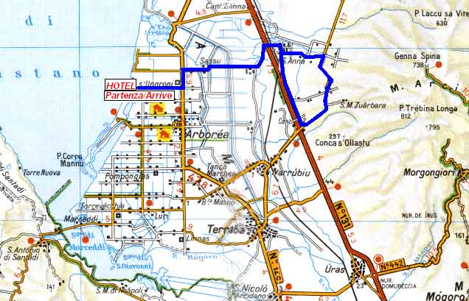

Single course (GranGiro/MedioGiro) 30k (overall climbing 90m)
This time the TTT will be fast and flat and so will encourage the fastest ride!
You depart from inside the hotel to go as far as the corner for the SS131: the road will be well-known because it is the same one you did the day before. Go as far as the turnoff for S.Anna and then turn right until you come back near the SS131; at the corner for Marrubiu go onto the local road which goes along beside the big highway and return first to the corner for S.Anna and so to the finish.

Green route-Tour: free While the racers play at being pros, you can go and discover the Sinis peninsula! Go through Oristano and then take whichever you find more interesting: you can go and pedal along the lake of Cabras to see the ruins at Tharros and the characteristic houses of S. Giovanni di Sinis or the beaches at Is Arutas and di Putzu Idu or all of this, in the same ride. Take it easy and remember that the roads are all flat …. Just don’t get lost!
NOTE: the prize giving will be early at 18.00 and in the Palacavallo while there will be a show (lasting about 1h30m) of kids riding their ponies or the very rare “little ponies of Giara” Free entrance for all.
The little riders, dressed in traditional costumes, accompanied by the sound of little sard tambourimes, will ride a star race and the choreographed Parigliette: it is a Sartiglietta and reproduces the famous Sartiglia of Oristano (a very old spectacular Sardinian horse joust) It is a sight not to be missed !

Friday 29 April: Turnoff for Ingurtosu –the coast of Nebida/Buggerru
- Meet up at the corner for Ingurtosu on the SS126 ( About 60k from the Horse Country Resort. The route to take is: Terralba, S.Nicolò Arcidano, Guspini, Arbus and then the SS126 towards Fluminimaggiore for 6 k to the turnoff for Ingurtosu).
- Race start : MedioGiro 9.30 – GranGiro 9.45; Tour : free start between 8.30 and 9.30
Maximum time at finish : MG 14.30; GG 14.45
Feed stops : MedioGiro 1+ finish line; GranGiro 1+ finish line; Tour only at the finish
Prizes : the first three overall winners (men/women) for the Grangiro and for the Mediogiro + raffle prizes amongst those present

This is a special day from every point of view.
The routes are the same for the Medio and the Grangiro (but the starts will still be separate)
It is the only start that takes place away (60k) from the hotel
It is the only climbing stage in the whole week: it is beautiful and difficult and puts on show first of all the woods and the surrounding area of the “iglesiente”, so the mining area near the town of Iglesias and then the stupendous seaside which starts with the enormous beach of Fontanamare (with the Island of Carloforte in the background) then continues with the high cliffs of Nebida, the “Sugar Loaf island” of Masua, and the splendid town of Buggerru with its beautiful beaches; all flavoured with this old mine workings although they are now decayed and abandoned
The road is a continual string of long climbs (with some short ramps with percentage climbs in double figures!) and technical descents on a perfect road surface with plenty of space to do battle from the first to the last kilometre.
At the end of the race we will have a final feed stop and theoretically it will be possible to return to the hotel to eat but we advise you to get the free packed lunch (which replaces lunch in the hotel and should be ordered at the hotel reception the previous day before 1500) and so enjoy a trip to the old mine workings of Ingurtosu or to the sea Piscinas. The mediofondo riders will therefore have a chance to see the route they did not race on Monday.

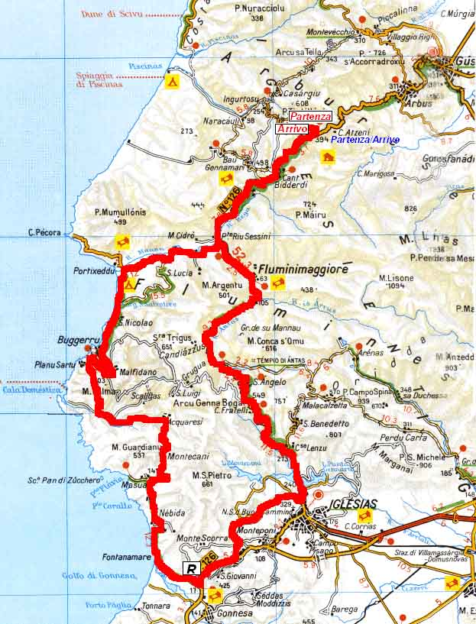

Single Course (GranGiro/MedioGiro) km 96 (overall climbing m. 1.688)

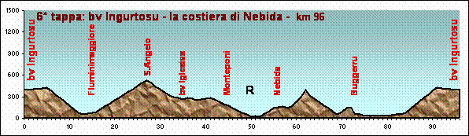

Right after the start descend to the corner for Buggerru. Follow the road for Fluminimaggiore and, after crossing through the little village, the road starts to climb slowly and constantly to 600m at the pass of S.Angelo (… it is a pity to not go to the Temple of Antas: the place is truly magical!) then descend to the outskirts of Iglesias. Turn right avoiding the town riding towards Monte Agruxiau and therefore towards the huge mine of Monteponi from where you descend to the beach at Fontanamare. A fast feed stop before facing the hardest part of the route which starts with the climb to Nebida (the road is carved out of the rocks in places and the panorama is distinctly fascinating!), continue with a brief descent towards Masua (splendid views of the rocks of the Pan di Zucchero) and then climb again towards the old mine at Montecani (a short but decidedly difficult climb). Ending this panoramic part of the route, you go back inland towards the mine works of Acquaresi and then to the sea (… a shame not to be able to see Cala Domestica!), then another short climb to a little plain which gives a spectacular view across to Buggerru, its beaches and the peninsula of Capo Pecora! On reaching the village, a short flat stretch takes you to the turnoff for Fluminimaggiore where the last climb starts which you already descended at the start of the race.

Green route-Tour: free
It is really difficult to advise what to see and what to miss out from this stage!
It all depends on your strength and the time you can and wish to spend cycling!
In any case, try to avoid stopping at the race start and go at least to the bottom of the descent at the turnoff for Buggerru.
If you are on form, we advise you to at least ride from this point; however, if you do so, this will be about 70k (Fluminimaggiore, Sant’Angelo, Iglesias, Fontanamare, Nebida, Mausa, Buggerru) with over 1000m of climbing
If you don’t feel up to that, you can go from the plain to the sea and, following the coast, get to Buggerru (but leaving the village a little bit to see the great view from above!) then turn back going down to explore the panoramic road towards Capo Pecora (… it’s a great thing to do, specially on a sunny day); this way you will do about 40k with only a bit more than 200m of climbing..

Saturday 30 April : kermesse of Arborea
- Participants meet at the road for S.Anna – on the corner of the highway SS131
- Starts : starting from 9.30 Tour : free
- Feed stops : none
- Prizes : the first three overall winners in each group.

We played this game at Alghero 2 years ago and everyone loved it: race in each of the age categories
NOTE: the race time of the kermesse will not affect the general classification of the Giro (the overall winners of the Giro will therefore be decided with the general classification after Friday 29th race) but only the classification by age category ; to make the race more interesting, the grangiro and mediogiro riders will be regrouped together with those of the same age group. First those in age group A will be called; then after 15 minutes those of age group B and so on.
The jury can group together any categories where there are too few participants (for example the women’s categories)
Each start will be 15 minutes after the one before so that each group can do the race without interference from other groups.
At the end of the race the first three from each group will be called directly to the prize giving and will go straight onto the podium.
The start will be near the exit for S.Anna, close by the turnoff for the SS131 while the finish will be at the hotel.

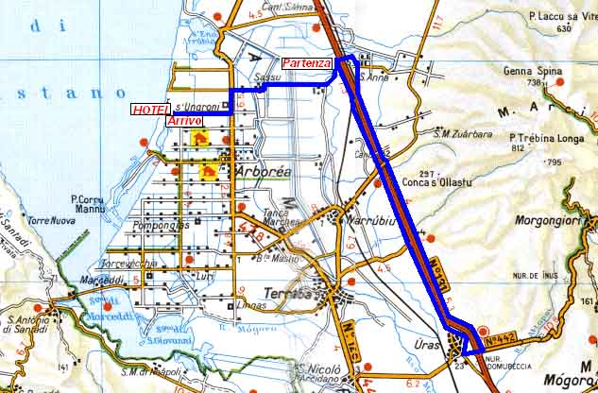

Single Course (GranGiro/MedioGiro) 40 km (overall climbing 130m)

The race will take place on the local roads which run along both sides of the highway (they were built during the building works to widen the SS131); they are roads which are absolutely free of traffic and will be all “ours” for a day.
You start by pedalling on the right of the highway, reach the corner for Marrubiu and Terralba and then exit towards Uras, going over to the other side of the hoghway and pedal down the left side of it; once back at the flyover at S.Anna continue to the final sprint at the hotel.
On this route, the groups will never cross (this is why we made the start at the corner for S.Anna and not at the hotel!) and the riders will have a chance for once to race only against those of the same age.

Green route-Tour: free
After a week on the bike…. You will be back in shape and so if you want, you can also race against those in your age group and try to not lose the wheel in front. Alternatively, you can have a day to yourself.

In the afternoon, right after lunch, there will be the prize giving of the Giro Sardegna with the usual raffle of the valuable prizes (there will be as usual the appreciated discounts for the Giro in 2012) then we will go to take the ferry at Porto Torres, Olbia or Golfo Aranci.

